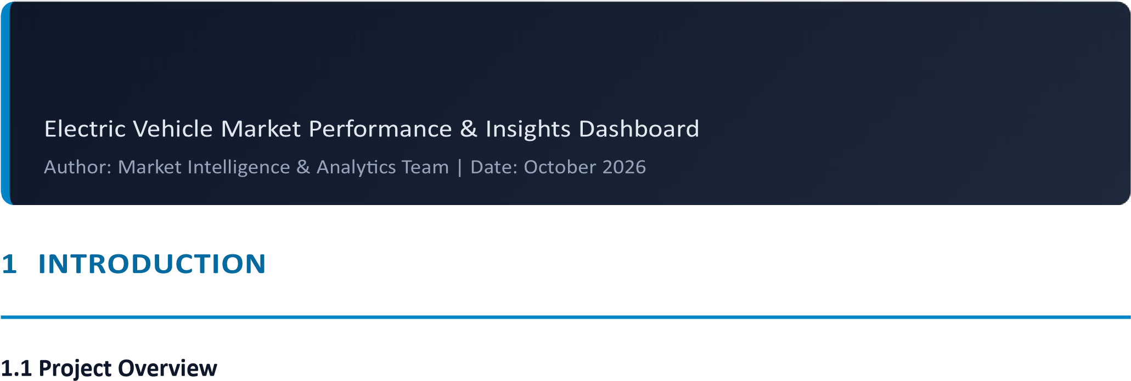
The Electric Vehicle Market Performance & Insights project provides a comprehensive dashboard and analytical tool designed to track, analyze, and visualize key trends in the global electric vehicle industry. By synthesizing market penetration rates, OEM leadership, battery pricing metrics, and charging infrastructure growth, the project translates complex datasets into actionable strategic intelligence.

1.2 Purpose
The main objective is to empower industry analysts, investors, and policymakers with interactive real-time visual insights. The solution simplifies complex automotive transition metrics and provides market transparency regarding regional adoption, powertrain splits (BEV vs. PHEV), and cost trajectories.

2. IDEATION PHASE

2.1 Problem Statement
Global EV market data is highly fragmented across regional registries, manufacturer press releases, and infrastructure reports. Stakeholders lack a centralized interactive hub to evaluate real-time OEM market shares, battery cost reductions, and regional charging readiness simultaneously.
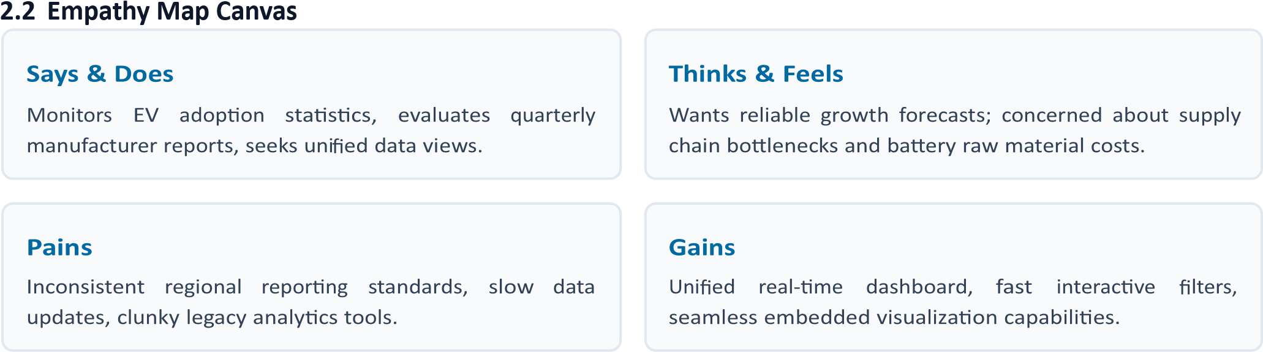

2.3 Brainstorming
Initial conceptualization focused on creating a hybrid analytics platform combining client-side interactive JS components (Chart.js, Tailwind) with deeply embedded enterprise BI visualizations (Tableau Public API) to balance performance and visual depth.

3. REQUIREMENT ANALYSIS

3.1 Customer Journey Map
The user journey follows three main stages: Access (landing on the dark glassmorphic portal), Exploration (filtering parameters by region, powertrain type, or FY period), and Insight Extraction (interacting with embedded Tableau charts and exporting summaries).

3.2 Solution Requirement
Functional: Multi-parameter filtering, dynamic KPI cards, embedded Tableau BI dashboard, real-time Chart.js rendering, toast notifications.
Non-Functional: High responsiveness, dark glassmorphism UI, page load speed under 2 seconds, cross-browser compatibility.

3.3 Data Flow Diagram

3.4 Technology Stack
Layer | Technologies Used | Purpose
Frontend UI | HTML5, Tailwind CSS, Lucide Icons | Responsive glassmorphism dark mode web layout
Visual Analytics | Tableau JavaScript API v2, Chart.js | Interactive BI embeddings & dynamic trend charts
Deployment | GitHub Pages, Git | CI/CD hosting and continuous availability

4. PROJECT DESIGN

4.1 Problem Solution Fit
The proposed design solves fragmentation by wrapping high-density Tableau workbooks within an ultramodern, lightweight front-end shell that delivers immediate key metric visibility alongside deep analytical drill-downs.

4.2 Proposed Solution
A single-page web dashboard (`index.html`) featuring glassmorphism design principles, four top-level KPI summary cards, global market dynamic filters, a live Tableau iframe wrapper with fallback loaders, and an OEM performance ranking leaderboard.

4.3 Solution Architecture
The front-end queries local data structures for immediate UI responsiveness while establishing an asynchronous JS bridge to Tableau Public servers to render heavy multidimensional data models smoothly.

5. PROJECT PLANNING & SCHEDULING

5.1 Project Planning
Development was executed over a 4-week structured sprint timeline, focusing sequentially on dataset collection, Tableau workbook authoring, web layout implementation, and cloud deployment.
Phase | Task Description | Duration | Status
Phase 1 | Data collection, cleaning & Tableau sheet creation | Week 1 | Completed
Phase 2 | UI/UX design, HTML/Tailwind wireframing | Week 2 | Completed
Phase 3 | Tableau API integration & Chart.js configuration | Week 3 | Completed
Phase 4 | Testing, optimization & GitHub Pages deployment | Week 4 | Completed

6. FUNCTIONAL AND PERFORMANCE TESTING

6.1 Performance Testing
Rigorous browser-level testing was executed to evaluate render speeds, asset responsiveness, and API call integrity under varied network constraints.
Tableau API Initialization: Verified interactive load time under 1.8 seconds with active spinner fallback. Responsiveness Test: Validated layout adaptability across desktop (1920x1080) and mobile viewports.
Filter Latency: Client-side JavaScript filtering executes in < 50ms without UI freezing.

7. RESULTS

7.1 Output Screenshots
The resulting application delivers an intuitive web portal containing real-time market data visualizers, interactive OEM ranking boards, and direct integration with Tableau Public workbooks.


8. ADVANTAGES & DISADVANTAGES
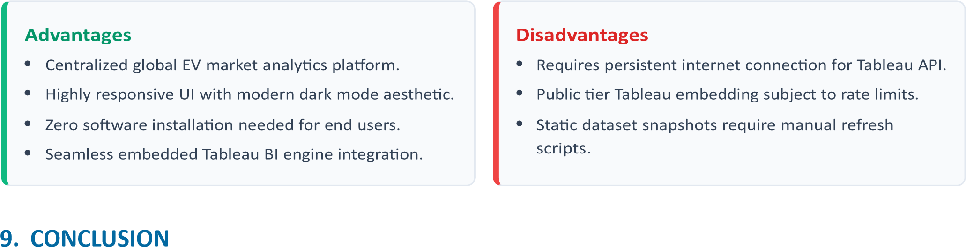

The Electric Vehicle Market Performance & Insights project successfully demonstrates the power of hybrid web analytics. By combining custom front-end design with enterprise BI visualization tools, the dashboard delivers an engaging, efficient, and insight-dense platform for analyzing the ongoing global transition toward sustainable mobility.

10. FUTURE SCOPE
Automated Data Pipelines: Integrate REST APIs to pull daily live sales updates from regional registries.
Predictive Analytics: Implement machine learning models to forecast regional battery price trends and market share shifts.
User Authentication: Add customized user portals allowing saved views, custom alerts, and exported PDF reports.

